                  
CURRICULUM VITAE
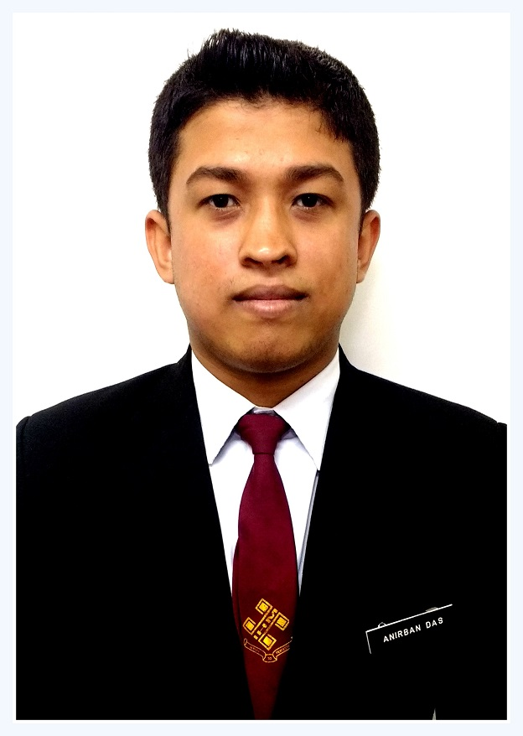
Anirban Das
Address : 22/6,Sitalatala Road, Dakshin Para,Barasat,North 24 Parganas,
Kolkata-700124
 Ph: +91 8336006419
Email Id: dasa978@gmail.com

Career Objective: To Work As An Employee In Your Prestigious Organization Will Give Me A Opportunity To Showcase My Talents & Contribute To The Organization In The Most Effective Way.
Work Experince:
Have Completed My Internship Programe At From The Lalit Great Eastern Kolkata, As A Part Of My Curriculum At Ihm Gangtok. I Have The Experience Of All The Main Departments As Follow:-
Food Production
Food & Beverages Service
Front Office
House Keeping
Working In Vivanta By Taj Begumpet 4 June 2018- Present.
Area Of Interest: FOOD & BEVERAGE SERVICE
Knowledge:
Basic Knowledge Of Fundamentals Of Computers, Typing, Ms Office, Browsing & Emailing.
Key Points:
Motivate And Lead Others To Approach Towards Problem In Confidence.
Quick And Smart Learner.
Having Flexibility At Work.
Very Jolly And Frankly Person.

 Educational Qualification :

Name Of The Examination | Board / University | Year Of Passing
Secondary | Wbbse | 2010
H.S | Wbchse | 2012
B.Sc In Hotel Management | Nchmct | 2017

Personal Achivement: Successfully Completed 5th Year Certificate Course As A Tabla Player, From Prachin Kala Kendra Chandigarh.

Personal Details :
Date Of Birth :: 04/08/1994
Father's Name :: Amar Krishna Das
Gender :: Male
Marital Status :: Unmarried
Nationality :: Indian
Language Known :: English, Hindi & Bengali
Hobbies :: Playing Tabla, Sports
Declaration:
I Hereby Declare That The Above-Mentioned Information Is Correct Up To My Knowledge And I Bear The Responsibility For The Correctness Of The Above-Mentioned Particulars.

Date : 20/6/2019
Place : Kolakta
(Anirban Das)

