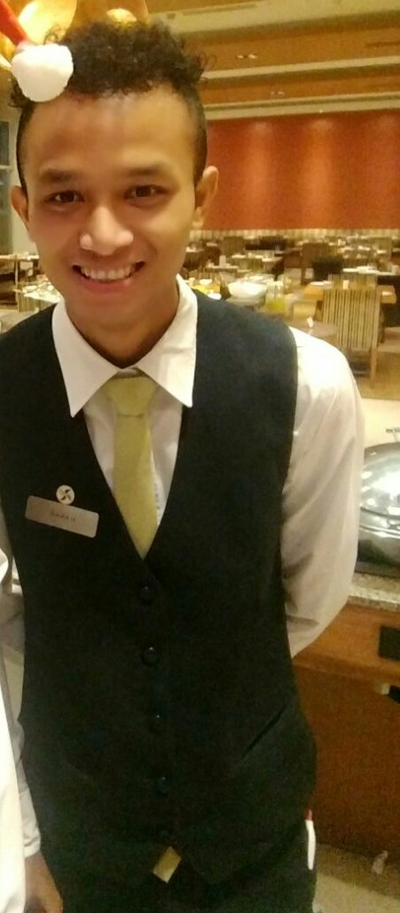  MANABJYOTI BORAH  Contact: +91-9678811653  Email:  manabjyoti@iam.ac.in Correspondence Address :IAM Institute of Advanced Management, Royal Regency, M R D Road, Bamunimaidan,Opposite FCI Godown, Guwahati  Permanent Address:VILL-Betoni chariali goan, P.O-Buri khowang,Dist-Dibrugarh( Assam) Pin-785676  Fathers Name:  LATE. Sarbeswar Borah  Date of Birth :31.07.1991  Marital Status : Single.  Sex : male  Language Known :  - ENGLISH.  - HINDI.  - BENGALI.  - ASSAMESE.  Nationality : Indian.  Strengths:  - Punctuality,  - Hard working,  - Positive Attitude,  - Good behaviour.  Hobbies:  - Reading news paper  - Observe people  - Singing  - Meeting new people, Reading  - Newspaper, Listening Music and  - Travelling new places | Career Objective:  Seeking the position of waiter in FOUR POINT BY SHERATON hotels where TWO year six months experience of providing professional, efficient, and friendly service in a major restaurant will be maximized to ensure total customer satisfaction.  Professional experience:  Senior GSA(Radisson Blu Guwahati)  Present -2019  ● Escort customer to their tables  ● Prepare and set tables following standard practice  ● present menu to guests and respond to question concerning menu items , then offer recommendation when asked to  ● Find out if customer are enjoying their meals or if they are having issues , resovle any complaint quickly  ● Explain to customer or guest how the different menu items are made , describing the various ingredients and the cooking methods  ● serve food , wine ,and other beverage to guest  ● Clear tables or counter of dishes and glasses and take them for cleaning at the kitchen  Duties and responsibility :  ● Handled 2 sections of the hotel restaurant in an efficient and enthusiastic manner  ● provide prompt and courteous food and beverage service to guest  ● performed breakfast buffet set up and replenished food items  ● Delivered room service orders  ● worked varying shift including weekends and holiday  Education and continuning professional Training:   ● Casual Training from kiranshree portico and Guwahati   ● One week restaurant training program.   ● 4 month industrial training in Radisson blu pune  ● working in four point by sheraton pune  Right now I'm working in radisson blu Guwahati  Computer Awareness:  - Diploma of computer software  - Basic knowledge of computer hardware  - MS Word, MS Excel and Power Point  - Comparable Knowledge of Internet Applications.

CAREER ACHIEVEMENTS / WORK EXPERIENCE

Date:27th 2015 to 16th December 2017.
Name of Company: Four Points by Sheraton
Viman nagoar (Pune)maharastra
5th mile stone
Industry of Company: Hotel
Position held: Steward (F & B Service)
Duties and Responsibilities:
To take order and provide professional service.
Ensure to provide proficient and professional Food & Beverage service to the
Guests by meeting and also exceeding their expectations.
Welcome the guests by greeting them as per the standards.
Any matter which may affect the interests of The Palms should be brought to
The attention of the Management
Facilitates the functioning of and / or oversees the functioning of Front Office
Department or any other Department in the Club when necessitated by
Circumstances and as mandated by the General Manager. This would be over
And above regular stipulated responsibilities and duties.

REFEREES

ADITYA GHOSH
Asst. Restaurant manager
(Four Points by Sheraton)
Ph- +91 77090 06687

ACADEMIC ACHIEVEMENTS / EDUCATION

Dates: 14 June 2010 to 4 July 2013
Qualification and Subject: BSc.HS (Hospitality Studies) University/College:University of PTU (IAM College guwahati )
Grade: Second Class
Subjects: Principles of Hospitality; Principles of Food & Beverage; French; etc

REFEREES

SALMA SULTANA .
FOOD AND BEVERAGE PROFESSOR
(Pride Institute of Hotel management Guwahati )
PH: 9508979447

Area Of Interest:

Food $ beverage,

Declaration:

I hereby declare that all information given above is correct to best of my knowledge.

DATE –8.8.2019 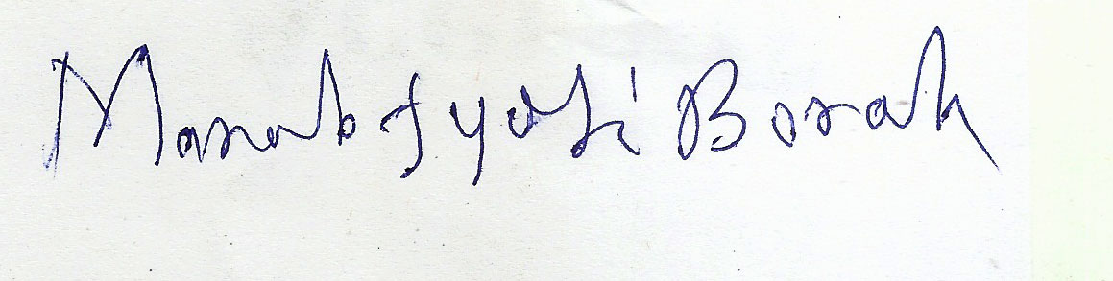

PLACE- GUWAHATI MANABJYOTI BORAH

