RESUME 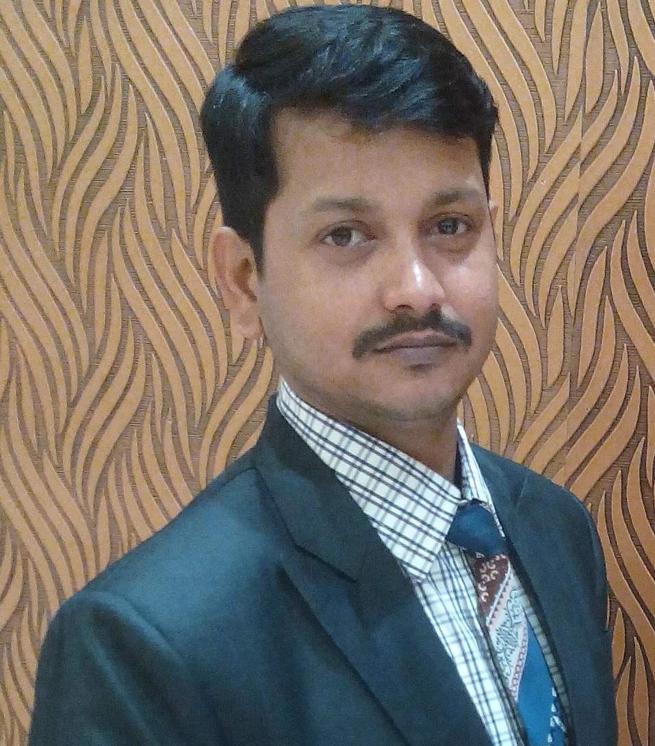

Prabhat Kumar Mondal
Permanent Address : 41,Yadav Nagar, Musakhedi, Indore.
Mobile: +91-9752553020
E-Mail: prabhatmondal007@gmail.com

Objective
To reach maximum possible proficiency in terms of Service and establish myself as a competent literate entity of the same & excel in exploring depths of the same and also to work in professional organization that offers opportunities for learning is engaged in maximization of stake holder through focusing on core competencies and has attention on the lifetime value of long term customer relationships.

Job Profile
- Overseeing the day to day operation of the Front office, Housekeeping & Food & Beverage Outlets including cleaning, floor plan lay-out, table settings and theme of the banquet.
- Training, supervising, promoting staff. Since good quality service is important managers strive to hire excellent staff.
- Working with the chef to determine menu plans on a daily basis, for special events or occasions or for groups or parties.
- Meeting, greeting and getting feedback from customers.
- Advertising and marketing the banquets within the community.
- Working, and developing relationships, with external suppliers to ensure the very best reputation within the industry, and receives the service required to ensure that the operational Food and Beverage team can deliver the highest quality product, and the highest financial return.
- Ensuring strict compliance with all relevant Hygiene and Safety legislation and requirements.
- Maintaining the F&B Management invoices and journals, manage and monitor expenditure associated with catering equipment repair, manage the asset register and assist in budget setting each year for the department
- Planning and implementations of new ideas and menu specifications each season, working closely with Central Support to ensure they fit with guidelines and are to the high quality our guests expect.

Key Skills

- Hospitality Operations Management
- Front- & Back-of-House Operations.
- Budgeting , Cost Controls & Breakage Control
- Handling guest enquiry
- Team building/Training/Supervision
- Inventory Management
- Guest Service Excellence
- Multi outlet Operations (Food & Beverage)
- Setting Standard Operating Procedures
- Strategic Marketing & Sales
- Handling guest complaints
Sodexo, Ahmedabad April, 2019 – Dec'2019

Worked as s Assistant Manager – HR (Recruitment)

- Sourcing through Job portals, head hunting, and references.
- Looking for entire operation of the client site.( Reliance ,Adani, Volvo etc.)
- Interviewing and closing the positions as per specifications within the stipulated timelines.
- Verifying duly authorized and accurately filled requisition with actual Budgeted manpower matrix.
- Visiting different location during Head hunting for recruitment purpose.
- Site Visit for promotion of Employee Referral schemes.
- Assisting in joining formalities after selection of candidates.

Hotel Mangal City, Indore July, 2016 – March,2019

Worked as a Sales Manager( Banquet & Room) in Indore biggest indoor banquet that is around 10500 sq. called Grande Mangalam -1, Grande Mangalam -2 (6700 sq.), Jashana (3200 sq.), Mansha (2400 sq.) and Mantrana (2300 sq.) with 76 Keys 3Star Hotel.

- Planning menu for an expansive repertoire of menus, along with portion standardization and supervision of food preparation & service.
- Spearheading the entire banquet operation related activities, including monitoring the food and drinks preparation.
- Coordinating the work of the staff and managing the team.
- Experimenting & presenting innovative ideas, styles and ensuring cost control measures.
- Maintaining quality and consistency of service for enhancing satisfaction amongst customers.
- Ensuring cleanliness in the work area & it is in order prior to the operation time.
- Conducting hygiene inspections and conveying feedback to operating staff as well as managers for gaps in actual vs. standardized norms.
- Responsible for corporate and Travel Agent Room Sales for the hotel.
- Identify new markets and business opportunities and increase sales.
- Represent Hotels in various events and exhibition.
- Conducts daily sales calls and arrange site inspection trips to hotels by corporate clients.
- Able to provide quick and timely responses, immediate communication to the properties, develop professional long term business relationships.
- Provide the highest quality of service to the customer at all times.
- Participates in sales calls with members of sales team to acquire new business and/0r close on business.
- Work closely with Revenue Manager to ensure proposed rate negotiations meet the financial needs of the hotels.
- Develop strong relation with on property front office team to ensure working in unity.
- Attending all department and hotel meeting as necessary.
- Builds and strengthens relationship with existing and new customer to enable future booking. Activities include sales calls, entertainment, trade show etc.
- Develops relationships within community to strengthen and expand customer base for sales opportunities.
- Closely following up on all business leads within 24 hour response time line to clients.
- Report to GM.

Grand Goa Exotica,Goa Oct. 2014 – May, 2016

Joined as Sales & Marketing Manager ( Room)

- Analyses current client base or target market for the hotel
- Devises new ways to expand that client base.
- Develops promotional and advertising materials for the hotel.
- Meet with representative and business that might require a hotel for conference and events.
- Networks with wedding planners and special event planners to increase hotel bookings.
- Design and advice special group rates and packages to increase larger bookings.
- Manage accounts of high profile clients.
- Process payments & applies discounts as necessary.
- Addresses and resolves any issues or complaints regarding sales or marketing.
- Ensure that guests are enjoying their stay at the hotel.
- Maintains positive relation with clients to encourage repeat and recurring business.

Hotel Mangal City, Indore Feb’2010 - Sept ‘2014

Joined as a Banquet Sales Executive in Indore biggest indoor banquet that is around 10500 sq. called Grand Mangalam -1, Grand Mangalam -2 (6700 sq.), Jashana (3200 sq.), Mansha (2400 sq.) and Mantrana (2300 sq.) with 75Keys 3Star Hotel.

- Planning menu for an expansive repertoire of menus, along with portion standardization and supervision of food preparation & service.
- Spearheading the entire banquet operation related activities, including monitoring the food and drinks preparation.
- Coordinating the work of the staff and managing the team.
- Experimenting & presenting innovative ideas, styles and ensuring cost control measures.
- Maintaining quality and consistency of service for enhancing satisfaction amongst customers.
- Ensuring cleanliness in the work area & it is in order prior to the operation time.
- Conducting hygiene inspections and conveying feedback to operating staff as well as managers for gaps in actual vs. standardized norms.
- Report to manager.

Indigo Nig Ltd,Lagos,Nigeria Feb’ 2007 - June’ 2009

Joined as Sales & Marketing Manager (Room & Restaurant).

- Develop action plans and set objectives for increased revenue and maximum profit for hotel management.
- Implement sales and marketing strategies necessary for attracting clients to patronize a hotel.
- Maintain a clear understanding of hotel policies and ensure compliance.
- Carry out research and analysis to identify new markets and business opportunities.
- Oversee the hiring and training of hotel sales representatives and other hotel personnel.
- Seek out business with large organizations such as churches, sports clubs or corporate firms to convince them to patronize their hotel.
- Prepare and distribute promotional and advertisement materials to create awareness for hotel products/services.
- Maintain a complete knowledge of all the services a hotel provides so as to conduct successful sales.
- Explain and notify clients of recent upgrades and available options for hotel services.
- Collaborate with event and wedding planners to ensure increased patronage and hotel booking.
- Assign job duties to hotel personnel and ensure effective performance of assigned tasks.
- Supervise the customer service unit of a hotel to ensure compliance with set standards of hospitality and customer service.
- Maintain contact with clients to obtain feedback and encourage continued patronage.

Radhakrishna Hospitality Services Pvt. Ltd., Mumbai Nov’ 2003 - Jan’ 2007

- Joined as Site Manager.
- To oversee entire operation of all departments.
- Conduct periodic review along with the departmental heads.
- Handling guest complain
- Menu planning along with chef.
- Prepare weekly report of vendors.
- Making duty roaster and ensure proper flow of manpower.
- Maintain attendance register of staff.
.

ITC Mugal Sheraton,Agra August’ 2001 - Sept’ 2003

- Joined as Housekeeping Executive promoted to Supervisor.
- Job order
- Issuing pass key
- Lost & Found
- Briefing room attendant
- Inspecting Guest room
- Releasing guest room.
- Check cleanliness
- Report to Executive Housekeeper

Professional Qualification:
- Completed Diploma in Computer Application
- Completed Financial Accounting

Client Servicing / Team Management
- Ensuring maximum customer satisfaction by achieving delivery of service quality norms.
- Executing policies & procedures in the operating systems to achieve greater customer delight.
- Interacting with clients, handle guests requests & resolving complaints.
- Training the staff in accordance to the company’s specification & standard procedure.
- Maintained and improved food and beverage profits by monitoring wastage and breakages and implementing remedial action when necessary.
- Preserve excellent levels of internal and external customer service.
- Design exceptional menus, purchase goods and continuously make necessary improvements
- Identify customer’s needs and respond proactively to all of their concerns.
- Lead F&B team by attracting, recruitin, training, and appraising talented personnel.
- Provide two way communication and nurture and ownership environment with emphasis in motivation and teamwork.

Academic Credentials

- Diploma in Hotel Management and Catering Technology from IHM, Kolkata & SBIHM, Kolkata 1998 - 2001.

- B.com from Magadh University 1995 to 1997.

- Higher Secondary (12th) from West Bengal Council of Higher Secondary Education 1993.

- Secondary (10th) from West Bengal Board 1991.

Linguistic Abilities: English, Hindi, Bengali, Nepali

Personal Details
Date of Birth: 15th October’ 1979
Father’s name: Late Premlal Mondal
Marital Status: Married

Date:

Place: ( Prabhat Kumar Mondal )

