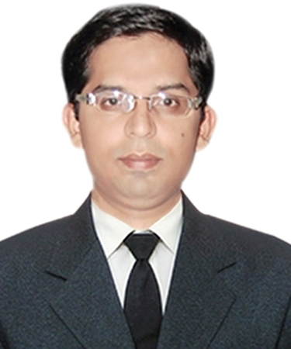 RIYAZ KAMAL
L-4, 2nd Floor Right Side,
Abul Fazal Enclave, OKHLA,
New Delhi – 110025
Ph.No. 09650443240, 09335148988.
E-mail ID:riyazkamal786@gmail.com
:riyazkamal0786@gmail.com
RESUME___________________________________________________________

CAREER OBJECTIVE:

To reach the pinnacle in the field of my desire and to obtain an exciting challenging position, enabling me to utilize my learning and interpersonal skills for the service of the organization so as to develop as a better human being and contribute the society positively.

Educational Qualification:

- M.B.A (Executive) in Finance & IB With 72% From Jamia Millia Islamia,New Delhi in year 2018.
- B.Tech in Electrical & Electronics Engineering With 69.46% from Kanpur Institute of Technology in year 2010.
- Class 10+2 with 62.6 % from CBSE Board in year 2006.
- Class 10 with 58.8 % from CBSE Board in year 2004.

IT SkillS:

OS : Win98, 2000, XP, VISTA, Windows 7.
LANGUAGES : C, C++, Core Java.
SOFTWARE : AutoCAD electrical, Versa pro, Stampplot pro, PSpice (simulation), Matlab 7.0.

TRAINING DONE:

- Vocational Training in Panki Thermal Power Station on 15/06/09 to 13/07/09 on Thermal Power Generation .
- Four Weeks Summer Training in Electric Loco Shed, Kanpur-3, Kanpur Nagar on Study of Motors and Commutators.
- Two Weeks Advanced Vocational Training on Ac & Dc Drives and Speed Control of Electrical Motors from Advanced Training Institute, Kanpur Nagar.
- Two Weeks Advanced Vocational Training on Industrial Automation using PLC from Advanced Training Institute, Kanpur Nagar.

PROJECT DONE:

- Developed Transformer Monitoring System as a part of Final Year Engineering Degree
Curriculum.

PROFESSIONAL EXPERIENCE:

- Presently Work as a Assistant Manager (Electrical- O&M) in BSES Rajdhani Power Limited
New Delhi. (Total 6 Years Experiences in Distribution)

- Six Months Working Experience as a Trainee Electrical Engineer in Designco Exporter and Manufacturer ltd. Moradabad , Subunit of Lohia Group, Moradabad.

EXTRA - CURRICULAR ACTIVITIES:

- Actively participated in scout and guide programme organized by Kendriya Vidyalaya.
- Participated in the Green Olympiad held on Kanpur.
- Participated in Abhivyakti-2008 held on 16/02/2008.
- Co-ordinator in Art Competition in Abhivyakti-2008 held on 16/02/2008.
- Done a Play at Udbhav-2007 held on 22nd September,2007.

AREA OF INTEREST:

Industrial Automation, Ac and Dc drives, Speed Control of Motors, Electronics Circuits, Computer Hardware, Power Electronics, Electrical Simulation etc.

PASSPORT DETAILS:

PASSPORT NO. : J6886899.
PASSPORT TYPE : P.
FILE NO. : LKO A00435711.
ISSUE DATE : 15/03/2011.
EXPIRY DATE : 14/03/2021.
PLACE OF ISSUE : LUCKNOW,U.P,INDIA.

PERSONAL DETAILS:

Father’s Name : Mohd. Shamim Iqbal.
D.O.B. : 20/03/1987
Nationality : Indian
Marital Status : Single
Language Known : English, Hindi.
Permanent address : 88/68 ,Prem Nagar, Kanpur Nagar ,Kanpur, U.P-208001.

HOBBIES:

Music, Graphic Animation, Windows Troubleshooting, Electronics Circuit, Ladder diagram programming, Software Collection, Repairing Electronic Goods especially Computer Hardware and Sudoku.

REFERENCE:

- Mr. Faisal Masood (Manager - Technical Marketing) at Schneider Electric , New Delhi
Contact No .: 09555859675.

- Mr. Arvind Yadav (AsVP) at BSES Rajdhani Power Ltd,New Delhi.
Contact No.: 09350110012.

Declaration:

I hereby declare that the information furnished above is true to the best of my knowledge and belief.

Date: _____________

Place: NEW DELHI ( RIYAZ KAMAL )

