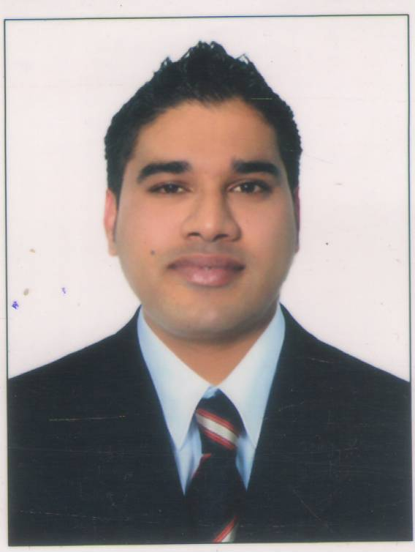
Rajat Kumar Bamrara

PLOT NO. 94 TULSI VIHAR COLONY SHYAMPUR ,
RISHIKESH ,DEHRADUN ,
UTTRAKHAND-249204 INDIA
MOBILE:+91(0)8447345946 ,
EMAIL: HYPERLINK "MAILTO:RAJAT.BAMRARA@OUTLOOK.COM" RAJAT.BAMRARA@OUTLOOK.COM
Skype :- rajat.kumar.bamrara
An outstanding hospitality and catering manager with a proven track record in delivering results in diverse environments and cultures. My range of skills include new business start up, staff training, salesmanship, liaise with suppliers, troubleshooting and implementing improvement procedures as well as documenting operating procedures and financial management.
Nov 2018 – Till Date Food and Beverage Manager Aloha on The Ganges
( A Unit of Leisure Hotels Ltd .)
Rishikesh Uttrakhand , India
Business Development & Sales Promotion
Develop and evolve best practices for selling and positioning.
Identify potential clients and extract higher amount of business by providing various solutions after understanding the clients needs.
Acquire and manage tie-ups with corporate clients for meetings, launch programmes and events at the hotel.
Keep track of competitor activities so as to fine-tune marketing strategies and product placement.
Analyse the market and perform comparative studies for setting new strategies for banquet and restaurant sales.
Client Management
Develop and manage effective relationships with key decision-makers in prospective organisations to meet business objectives.
Establish credibility and rapport with people at multiple levels and develop good customer relationships at all times.
Personally and frequently verify that clients receive the best possible services.
Ensure services provided under floor management process are always carried out to as per defined standards with the utmost efficiency, consistency and courtesy.
Quality and Process Improvement
Develop & streamline systems to enhance operational effectiveness and meet goals within the cost, time & quality parameters.
Maintain service standards in accordance with established policies and procedures of the hotel. Oversee the hygiene standards as per the protocol and strive for further improvements. Evaluate, respond to and take necessary & timely action regarding guest comments and queries.
Promotion and Event Management
Organise wine dinners, new events and functions in the food and beverage department.
Tie-up with liquor companies for sponsorships, promotions and other activities in the hotel.
Oversee conferences and exclusive outdoors and destination corporate events.
Operations
Prepare annual budget and control the costs according to the budget & achieve the budgeted revenues.
July 2017- Nov 2018 General Manager operation The Great Kabab Factory New Delhi ( New Opening Projects)
Dec16–July2017 Assistant Food and Beverage Manager Radisson Blu,
Greater Noida, India
Administration and supervision of daily operations of all Food & Beverage outlets
Preparing the Annual Business Plan and budgets for Food & Beverage Division and conducting monthly and quarterly reviews of actual performance against projected performance, as per the Business Plan.

Conduct quarterly audits of Brand Standards, prepare action plans for bridging audit gaps and supervise execution of the same.

Preparing the Food & Beverage Marketing Plan and developing and supervising the implementation of the F&B Activity Calendar.

Develop and supervise training programs for associates as per prescribed organization processes.

August 16 – Dec 16 Restaurant General Manager The Great Kabab Factory
Dhaka, Bangladesh

Administration and supervision of daily operations of all Food & Beverage outlet operations – including 120-seater .
Forecasting, planning the budgets to maximize the revenue & reducing the operational cost of department

Regulate inventories and create menu experiences to ensure that the hotel’s Beverage Program is kept dynamic and contemporary.

Enhance guests’ Events experience by producing themed coffee breaks and menu concepts.

Development of training programmes for all food & beverage management and line associates

Create concepts for promotions of Food & Beverage activities, initiate and supervise the execution of outlet promotions.

Reporting to The Vice President Operations & leading a team of 110.

Oct 15 – July 16 Food & Beverage Operation Manager Zerzura Qutab hotel
KatwariyaSaria New Delhi , India

Daily operation outlet operations – including 200- cover
Developed the banquets team for executing large scale ODC’s and institutional catering

Developed packed food segment amongst corporate and residential complex

Initiated different pricing mechanisms for attracting social functions

Enhance guests’ Events experience by producing themed coffee breaks and menu concepts.

Development of training programmes for all food & beverage management and line associates

Create concepts for promotions of Food & Beverage activities, initiate and supervise the execution of outlet promotions.

July 14 – Sept 15 F & B Operation Manager Bukhowa investment LLC
Dubai , U.A.E.
Prepare and regulate the critical path for opening of all (16) Food & Beverage QSR outlets, including Japanese, Thai, India , Italian cuisine

Plan, source and execute the purchase of operating equipment, FF&E, linen and uniforms.

Prepare and supervise the implementation of training plans and programs.

Prepare Local Standard Operating Procedure for Food & Beverage Operations, based on Carlson SOP, and supervise implementation of the same.

Establish par stocks for beverage and general operating supplies; plan, source and execute the purchase of all general operating supplies for restaurant and events operations.

Prepare and execute the Pre-Opening Marketing Plan for Food & Beverage.

Prepare punch lists for all outlets and co-ordinate with projects for the hand-over process of all F&B Outlets and Kitchen.

June 13 – February 14 Restaurant Manager Ramada Plaza JBR,
Dubai Marina, U.A.E
To manage the outlet ( All Day Dining , Coffee Shop) efficiently according to the established concept statement providing a courteous, professional, efficient, and flexible service at all times following hotel standards of performance.
Supervising & training the team members in order to ensure maximum levels of performance, also motivating them to provide excellent services in order to retain the guests.
Involved in budgets, profit & loss statement for various food festivals organised within the restaurant in order to maintain the profitability of the restaurant.

April 12 – June 13 Assistant Manager Mangrove Hotel ,
R.A.K., U.A.E
Involved (pre-opening) in the successful opening & running of 180 covers restaurant & bar lounge. Primary responsibilities include handling the F&B portfolio.
Preparing budgets in order to maximise the financial gains & reducing the operating cost of the organization.Hiring of new staff, taking decisions on their wages, working hours & setting their KRA‘s

Dec 10 – April 12 Food and Beverage Supervisor Ramada Sharjah ,
(Pre-Opening) Sharjah, UAE

Dec 09 – Dec 10 Bar Supervisor Al Murooj Rotana,
Dubai , UAE
June 07 – Dec 09 Sr. Captain Danat Resort Jebel Dhanna,
Abu-Dhabi, UAE

June 05 – May 07 Server The Ashok ,
New Delhi, India
Professional Training and Education
Bachelor Of Arts (Maths, English, Economics) HNBGU Uttrakhand (2002-2005)
Diploma in Hospitality Management from Uttranchal Food Craft Rishikesh (2003-2005)
Complete understanding of management roles in a pre-opening and under renovation restaurant.
Star & Superstar Programme
Environment, Health & Safety Procedures
Internal Auditor certified by HACCP, Dubai, UAE.
Personal Details
Date of Birth : 13th August 1986
Nationality : Indian
Languages : English, Hindi and Elementary French & Arabic
Marital Status : Married
Passport No : Z3970050
Referees : Available upon Request

