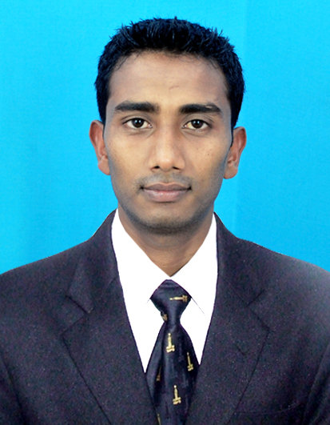
RESUME

RAJU KUMAR THAKUR

Postal Address: - Ramji Pan Dukan
Japhou bazaar
Chandel District, Manipur
Pin – 795127

Telephone: Mobile No:-+91 8709745916
+91 9810867480

E-mail id: - rajukr.88thakur@gmail.com

EXECUTIVE SUMMARY:-
I am a well presented person, outgoing and sociable. I believe I am highly skilled and have much to offer potential employers and their clients I am very experienced working with people. I am able to work individually and as part of a team very well.

OBJECTIVE: -

To achieve my dream in Hospitality Industry through honest effort and hard work and to add the value to the organization.

- Soft Skills
- Creativity
- Communication Skills
- Computer Skills
- Problem Solving & Decision Making.

ACADEMIC CREDENTIALS:-

- Xth from Maha Union Government High School under the Board of Secondary Education Manipur in 2008.
- XIIth from United College of Lambung, Chandel under the Council of Higher Secondary Education Manipur in 2010.
- Completed B.A in United College of Chandel from Manipur University, 2015

PROFESSIONAL QUALIFICATION:-

- I have done one year Diploma in Aviation and Hotel Management from NIPS Group of Hotel Management Institute, Kolkata under BSS, Govt. of India.
- I have completed my two month Industrial training in F&B and Front Office from Relish Hotel in Vadodara, Gujarat.
- Basic course and D.T.P in computer.
- Knowledge of “IDS, Inmkey,Hotelozix Software in Front Office.
- Knowledge of “PMS - Opera, Micros” Software in Front Office.
- Onity-Key Card Software.
- Participating Cricket tournament in College.
- Attention to detail and aptitude to maintain a very hygienic environment.
- Awarded as an Employee of the Month (July’2014) in Golden Palms Hotel and Spa, Goa
- Awarded as an Employee of the Month (Nov’15) in Country Inn and Suites by Carlson, Delhi
- Awarded as an Employee of the Month (June’16) in Country Inn and Suites by Carlson, Delhi

Experience Summary:

Hotel Name | Month and Year | Designation | Duration
Makemytrip.com (Gurgaon, New Delhi ) | 28th Feb’2011 to 22nd April’2013 | Sales & Operation Executive | 2yrs and 2 month
Golden Palms Hotel and Spa 4* (Colva South, Goa) | 2nd Sept’2013 till 10th Sept’15 | Front Office and Reservation Associate | 2 Years
Country Inn and Suites By Carlson (Chhaterpur - Delhi) 4*  Country Inn and Suites By Carlson (Saket - Delhi) 4* | ^{05th Oct’2015 -27th Nov’2016}  ^{08th Feb’17 – 11th Apr’17} | Front Office and Reservation Supervisor | 1 year and 3 month
Tree of Life Resorts & Hotels (Varanasi) 5* | ^{22nd Oct’2017 – 07th July’19} | Front Office Executive | 21 month
Pushkar Resort (Pushkar, Rajasthan) 4* | ^{11th July’19 till date} | Assistant Manager -Front Office

SKILLS AND ABILITIES:

- Honest, work as a team and respect others.
- Hard-working and always try my best.
- Good command over English, Hindi and Manipuri language.
- Possess excellent organizational and time-management skills.
- Have a positive attitude and a smile for all time.
- Enthusiasm and have outstanding customer service skills.
- Enjoy working with people and have a welcoming and sociable personality.

HOBBIES:-

- Playing Cricket and listing to music.

PERSONAL INFORMATION:-

Date of Birth : 05th May 1992.
Father’s name : Mr. Muktar Thakur
Father’s occupation : Barber
Marital Status : Married

Date: Raju kumar Thakur
Place: Signature:

