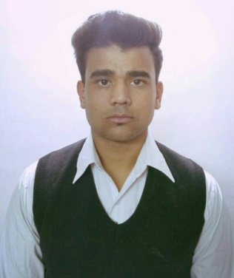
CURRICULUM VITAE
RISHAV TAHKUR
VILL.DHAROUN, P.O HIMMER, TEH. BHORANJ,
DISTT.HAMIRPUR, HIMACHAL PRADESH.
Mob: 8627036316.
E-mail: rt5631512@gmail.com

CAREER OBJECTIVE
- To make my career in hotel management field by using my good management skills for the mutual growth.To achieve set goals in my profession with hard work, sincerity and discipline with full faith in God.
PROFESIONAL QUALIFICATION
- Diploma in FOOD PRODUCTION from I.H.M SHIMLA.
EDUCATION QUALIFICATION
- 10+2 From HP BOARD.
- 10th From HP BOARD.
WORK & EXPERAINCE
- Industrial training from REDFOX by LEMON TREE HOTELS.
- Currently work in cardinal royale retreat hotel spa shimla.
KEY SKILL
- Team management.
- Hard working.
- Disciplined.
- Strong work ethic.
HOBBIES
- Cooking.
- Bike riding.
- Visiting new places.

PERSONAL DETAILS
- Name : Rishav Thakur.
- Date of birth : 20-04-1999.
- Father’s name : LATE. Sh. Ramesh chand.
- Nationality : Indian.
- Marital status : Unmarried
- Sex : Male.
DECLARATION
- I hereby declare that the information furnished above is true to the best of my knowledge and belief & nothing has been cancelled therein.

DATE :
PALACE : ( RISHAV THAKUR )

